**DAILY ONLINE ACTIVITIES SUMMARY**

|  |  |  |  |  |  |  |  |  |
| --- | --- | --- | --- | --- | --- | --- | --- | --- |
| **Date:** | **31-05-2020** | | | | | **Name:** | **Deeksha D Poojary** | |
| **Sem & Sec** | **VIII Semester & A Section** | | | | | **USN:** | **4AL16CS026** | |
| **Online Test Summary** | | | | | | | | |
| **Subject** | | **Internet of Things** | | | | | | |
| **Max. Marks** | | **20** | | **Score** | | | **19** | |
| **Certification Course Summary** | | | | | | | | |
| **Course** | **Introduction to Hadoop** | | | | | | | |
| **Certificate Provider** | | | **Great Learning** | | **Duration** | | | **4 Hours** |
| **Coding Challenges** | | | | | | | | |
| **Problem Statement: Find the quadratic equation.** | | | | | | | | |
| **Status: COMPLETED** | | | | | | | | |
| **Uploaded the report in Github** | | | | | **YES** | | | |
| **If yes Repository name** | | | | | **deekshapoojari** | | | |
| **Uploaded the report in slack** | | | | | **YES** | | | |

Online Test Details:



Certification Course Details:



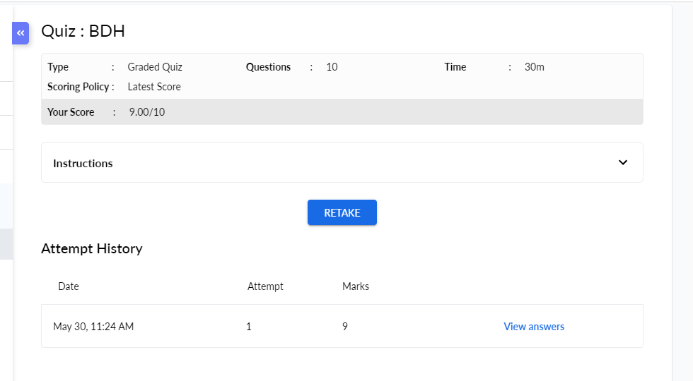



Coding Challenges Details:

|  |
| --- |
|  |
|  |
|  |
|  |
|  |
|  |
|  |
|  |
|  |
|  |
|  |
|  |
|  |
|  |
|  |
|  |
|  |
|  |
|  |
|  |
|  |
|  |
|  |
|  |
|  |
|  |
|  |
|  |
|  |
|  |
|  |
|  |
|  |
|  |
|  |
|  |
|  |
|  |
|  |
|  |
|  |
|  |
|  |
|  |
|  |
|  |
|  |
|  |
|  |
|  |
|  |
|  |
|  |
|  |

**Program1:**

**#include <iostream>**

**#include <cmath>**

**using namespace std;**

**int main() {**

**float a, b, c, x1, x2, discriminant, realPart, imaginaryPart;**

**cout << "Enter coefficients a, b and c: ";**

**cin >> a >> b >> c;**

**discriminant = b*b - 4*a*c;**

**if (discriminant > 0) {**

**x1 = (-b + sqrt(discriminant)) / (2*a);**

**x2 = (-b - sqrt(discriminant)) / (2*a);**

**cout << "Roots are real and different." << endl;**

**cout << "x1 = " << x1 << endl;**

**cout << "x2 = " << x2 << endl;**

**}**

**else if (discriminant == 0) {**

**cout << "Roots are real and same." << endl;**

**x1 = (-b + sqrt(discriminant)) / (2*a);**

**cout << "x1 = x2 =" << x1 << endl;**

**}**

**else {**

**realPart = -b/(2*a);**

**imaginaryPart =sqrt(-discriminant)/(2*a);**

**cout << "Roots are complex and different." << endl;**

**cout << "x1 = " << realPart << "+" << imaginaryPart << "i" << endl;**

**cout << "x2 = " << realPart << "-" << imaginaryPart << "i" << endl;**

**}**

**return 0;**

**}**